**CALL ROOM CHECK**

**Pease note that athletes are not allowed to take the following items to the Field of Play:**

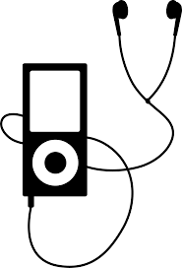

**Mobile Phones**

**Music Players**

(MP3s, CD-players, iPod or similar)

**Radio Receivers** or **Transmitters** &

**Video** or **Cassette Players** or **Recorders**



**Tape, chalk etc. for markings**

(other than provided by the LOC)

**Computer Devices**

**Photo** or **Video Cameras**

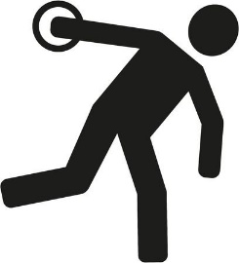

**Any other item deemed inappropriate by the Call Room staff**

**Throwing implements** or **parts of implements**

**Shoes with too many spikes** or **over-sized spare spikes**